Part 1: Autonomous Shipment's Trial: Driving the Future of Delivery
- Introduction to the Business problem:
With autonomous robot drones, Autonomous Shipment, a freshly founded firm in Leeds, is redefining autonomous last-mile logistics and last-leg logistics. The fundamental idea is that, with support from venture capitalists and the UK government, automating deliveries will not only provide customers with speedier service but also streamline our operations and reduce costs. The upcoming trial launch in Leeds will involve collaborating with other stores, including those selling food, clothing, sports, and technology. In view of the impending robot deployment in Leeds, the management of Autonomous Shipment needs to make two very important decisions:

- Choosing the ideal type of robot for the study in accordance with predefined criteria and guidelines
- Allocating the selected robot strategically among multiple retailers through optimization.
These choices, which balance the company's objectives and financial constraints, are critical to the trial's success. The analytics team's methodology for completing these duties is described in this paper, which also presents findings with concise explanations and figures.
1.1. Optimal Robot Selection:
1.1.1. Synopsis:
This report's part on selecting the best robot prototype for the experiment emphasizes utility maximization in accordance with predetermined standards. Based on five main criteria—Carrying Capacity, Battery Size, Average Speed, Cost per Unit, and Reliability—the four prototypes that have been identified are assessed: Archer, Bowler, Deviant, and Corner. Figure 1.1.1.1 contains quantitative information about each prototype's performance in relation to these standards.

Robot  Prototype | Carrying Capacity  (Litres) | Battery Size  (Hours) | Average Speed  (Km/h) | Cost Per Unit  (GBP) | Reliability  (Hours)
Archer | 45 | 18 | 6 | 5210 | 22
Bowler | 50 | 18 | 4 | 6250 | 24
Corner | 60 | 12 | 4 | 4500 | 24
Deviant | 40 | 24 | 10 | 7100 | 32
Figure 1.1.1.1: Robot Specifications

Figure 1.1.1.2 shows the criteria-wise weightage ratings that were simultaneously determined by the management team based on the criteria's prioritizing as of the July 2023 meeting.

Weightage | Carrying Capacity  (Litres) | Battery Size  (Hours) | Average Speed  (Km/h) | Cost Per Unit  (GBP) | Reliability  (Hours)
Weightage | 5% | 20% | 10% | 25% | 40%
Figure 1.1.1.2: Criteria Weightages
Selecting an effective Multiple Criteria Decision Analysis (MCDA) method is required in order to identify the best alternative among the four robot kinds. Subsequently, the data will be processed using the selected MCDA method, which will result in a recommendation that is in line with the decision-maker's utility-maximizing viewpoint and adheres to the given criteria and their associated weight.

1.1.2. Choice of MCDA method:
Despite the inherent robustness provided by the Analytic Hierarchy Process (AHP), the Technique for Order Preference by Similarity to Ideal Solution (TOPSIS) is found to be the most advantageous approach for the given data when it comes to choosing the most appropriate robot prototype. At first glance, AHP appears appropriate due to its systematic methodology of analyzing criteria via pairwise comparisons. However, it's important to recognize that AHP relies on subjective assessments in these analyses, which highlights potential difficulties. Considering these issues, using TOPSIS is beneficial. TOPSIS directly addresses the issues with subjective judgement associated with AHP by offering an objective ranking based on distance from the negative ideal solution and proximity to the ideal solution, all without the requirement for explicit weights.
When prioritizing effective communication and widespread acceptance of decisions, the appeal of TOPSIS lies in its simplicity and transparency. Figure 1.1.2.1 outlines the criteria-wise objectives to either maximize or minimize.

Min-Max Criteria | Carrying Capacity  (Litres) | Battery Size  (Hours) | Average Speed  (Km/h) | Cost Per Unit  (GBP) | Reliability  (Hours)
Min-Max Criteria | Max | Max | Max | Min | Max
Figure 1.1.2.1: Min-Max Criteria

The process of applying TOPSIS entails normalizing the decision matrix, which contains numerical information on parameters for every prototype, including carrying capacity, battery size, average speed, cost per unit, and reliability. This normalization guarantees a uniform scale for impartial evaluation. The Management Priority file is then used as the basis for computing the priority-weighted normalized values. The greatest and worst performances are represented, respectively, by the positive and negative ideal solutions that the algorithm then computes.

PIS | Carrying Capacity | Battery Size | Average Speed | Cost Per Unit | Reliability
PIS | 0.03 | 0.12 | 0.09 | 0.15 | 0.25
NIS | 0.02 | 0.06 | 0.04 | 0.06 | 0.17
Figure 1.1.2.2: PIS and NIS Values

TOPSIS identifies the most advantageous option with the shortest distance to the positive ideal solution and the longest distance from the negative ideal solution by calculating the Euclidean distances of each prototype from these ideals. This method seamlessly complies with the requirements for an effective decision-making process. Figure 1.1.2.2 shows the relevant PIS and NIS criteria wise scores.

1.1.3 Recommendation of Ideal Prototype:

Figure 1.1.3.1: Selection of robot with the highest TOPSIS score.

According to the investigation, the robot type Deviant is chosen as the most appropriate robot for the experiment because it meets or exceeds a number of important requirements, all of which help to explain its overall superior rating in the TOPSIS analysis. The "Deviant" performs exceptionally well in key areas, with the largest battery size (24 hours), average speed (10 km/h), and reliability (32 hours) among the options. The "Deviant" is the best choice among the robot prototypes presented, despite its lesser carrying capacity (40 Litres) and higher cost per unit (7100 GBP). These disadvantages are offset by its strengths in the weighted criteria.

1.2. Robot Allocation Methodology:

1.2.1. Summary:

Deciding upon the most appropriate robot for the analysis, this section explores the strategic distribution of autonomous robots among various store types, such as grocery stores, clothing stores, and sporting goods stores, while adhering to budgetary restrictions and trial duration requirements. The experiment is conducted within crucial commercial limitations that are necessary for this autonomous robot delivery endeavor to succeed. A crucial element is the 250,000 GBP budget cap, which covers both the cost of each robot individually and operating expenses. Grocery, clothing, and sporting goods stores each have different problems that call for specific fixes. Grocery stores expect nine orders per robot per day, but apparel stores and sporting goods stores aim for six and four orders, respectively.

Each robot's monthly operational costs are different for each of these retail types. Weekly technician man hours and packing protocols specific to each store are closely related. The main objectives of the trial are to make sure that each store has at least five robots, to maximize daily orders, to manage a cap of 250 hours for technicians, and to stay within the allocated budget.

The goal is to maximize daily orders while taking the given limits into account by using goal programming as a tool for decision-making. An ideal allocation technique that supports the trial's overall aims is provided by goal programming, which enables a methodical approach to balancing and accomplishing numerous objectives.
1.2.2. Choice of Optimization method:

The best approach for this task is the linear optimization strategy. When dealing with issues that have a single objective function and take linear constraints into account, this approach works especially effectively. Since the main goal in this particular situation is to maximize the number of orders that are finished each day, linear optimization is the most appropriate strategy. Lexicographic goal programming and goal programming are commonly utilized for handling several competing objectives that require simultaneous optimization. To get the best result, linear optimization entails creating a linear objective function and placing linear constraints on the decision variables. We identify the following choice variables in our scenario:

Constraint | Grocery Store | Clothing Store | Sport Equipment Store | Actual | Target
Cost | 8700 | 8100 | 7700 | 244300 | 250000
Labor | 10 | 7 | 5 | 250 | 250
Number of Orders | 9 | 6 | 4
Min No of Robots | 5 | 5 | 5
 | xg | xc | xs
Decision Variables | 19 | 5 | 5 |  | Maximized Number of Orders per day
 |  |  |  | Objective function: | 221
Figure 1.2.2.1: Linear Optimization Table

Let xg, xc, and xs stand for the number of robots to be assigned to the food store, clothes store, and sports equipment store, respectively, in accordance with table 2.2.2.1. Therefore, $9*xg+6*xc+ 4*xs$is the equation we need to maximise. To make sure the solution complies with the specifications, the following restrictions are also taken into consideration.$7100*xg+1600*xg+7100*xc+1000*xc+7100*xs+600*xs≤250000$ is the cost constraint.Work Limitation: $10 * xg + 7 * xc + 5* xs≤250$Robot Allocation Minimum: For the duration of the experiment, each store must have a minimum of 5 robots.

Recommendation on Allocation Strategy:

The trial's proposed course of action is to deploy 29 autonomous robots throughout several stores in order to efficiently manage a maximum daily volume of 221 orders, based on the results of the Linear Optimization analysis. In order to accomplish this, the grocery store is assigned 19 robots under a customized allocation scheme, while the clothing and sports equipment outlets each receive 5 robots. This allocation keeps the overall cost within the allocated budget of 250,000 GBP while optimizing order fulfilment and ensuring strict adherence to budgetary limitations. Additionally, it respects the weekly labour cap of 250 hours and is in line with workforce limitations.

Figure 1.1.3.1: Robot Allocation Strategy – Recommended

This suggested allocation approach strikes a balance between the primary objective of optimizing daily order completions and the necessity of cost-effectiveness, serving as a strategic business proposal. The recommended strategy, which respects labor and financial limits, is a wise and practical choice that will improve order delivery efficiency as a whole.

Summary Response to Management:
1. The thorough research highlights the "Deviant" robot as the best option for our forthcoming experiment, demonstrating outstanding performance in critical areas including battery capacity, average speed, and dependability. Although the "Deviant" has a somewhat higher unit cost and a slightly lower carrying capacity overall, it nonetheless meets all of our commercial goals.

2. Our strategic directive for the trial suggests the deployment of 29 autonomous robots, with a customized allocation plan dispersing 19 robots to the grocery shop and 5 each to the clothes and sports equipment stores. This recommendation is also based on the meticulous selection of the most suited robot. This distribution not only optimizes order fulfillment efficiency but also guarantees strict adherence to our predetermined limitations. Our suggested course of action is a prudent commercial choice that has been thoroughly calibrated to improve operational effectiveness and meticulously manage the labor and financial components.

Part 2: "The Factors that Determine Customer Value"
  - Introduction to the Business problem:
'Drinks@home.uk' is a direct-to-consumer e-commerce platform that offers a global selection of alcoholic and non-alcoholic beverages. The principal aim is to gain a thorough understanding of the demographics and habits of customers, with a specific focus on two critical business inquiries. The first inquiry explores the intricate interactions between variables like age, income, and website involvement in order to determine the key elements impacting users' buying patterns on the website. The following requirement is to make a strategic proposal from three possible marketing campaigns that are intended to increase revenue. Every choice, aimed at particular clientele or marketing strategies, will be carefully assessed in light of the knowledge gathered from the preliminary investigation. 'Drinks@home.uk' will be guided toward an optimized marketing strategy that is in line with customer behaviors and preferences by this report, which aims to identify the primary drivers of customer spending.

  - Data Understanding and Insights:

Operating solely within Great Britain, the platform has collected information on 400 clients, including order value, the source of the advertisement that drew them in, age and income estimates, the amount of time they spend on the website on average each week, and their interactions with online voucher pop-ups. Finding the key elements that influence each customer's purchasing behavior on the website, whether positively or negatively, is the objective.

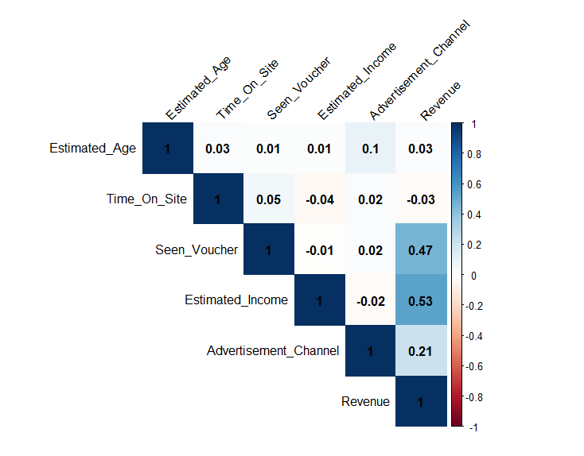

Figure 2.2.1: Correlation Matrix for the Customer Information

Significant factors affecting customer revenue: Important information about the factors impacting consumer spending on our website is revealed by the correlation matrix study. The results indicate that there are strong positive relationships between revenue and variables like the use of vouchers and higher anticipated income. This suggests that targeted voucher promotions have an impact and that customers with higher income levels are crucial. On the other hand, age and amount of time spent on the website have less of an impact on income. Our marketing methods can be improved with the help of these studies, which highlight the potential benefits of customized promotions for particular customer categories.

Beneficial Impact of Seen Voucher on Revenue: Customers who utilize vouchers have a mean revenue of about £89.50, which is substantially higher than that of their non-interacting counterparts, who have a mean revenue of £70.01. This highlights a profitable relationship between the use of vouchers and higher sales. The results highlight how crucial it is to optimize voucher-centric marketing strategies as a key strategy for increasing consumer spending and promoting total revenue growth.

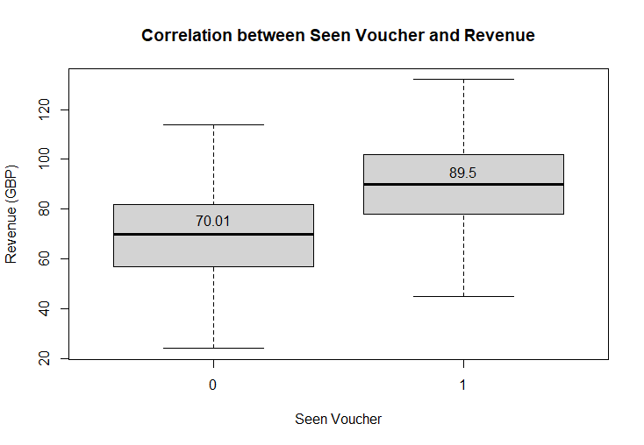

Figure 2.2.2: Comparison of Revenue based on Seen Voucher

Variations in revenue earned by various advertising channels: After examining the precise average revenue figures for each of the advertising channels, Channel 4 is clearly the highest revenue producer, with an average revenue of £85.41. Channels 2 and 3, with mean revenues of £81.95 and £81.12, respectively, follow closely after. Based on historical data, this analysis emphasizes how crucial it is to properly allocate resources and prioritize ads, particularly on Channel 4. This strategy has the potential to significantly increase revenue for the company. We can maximize the financial rewards from our advertising strategy and target our efforts towards the most highly profitable channels. Variations in revenue earned by various advertising channels.

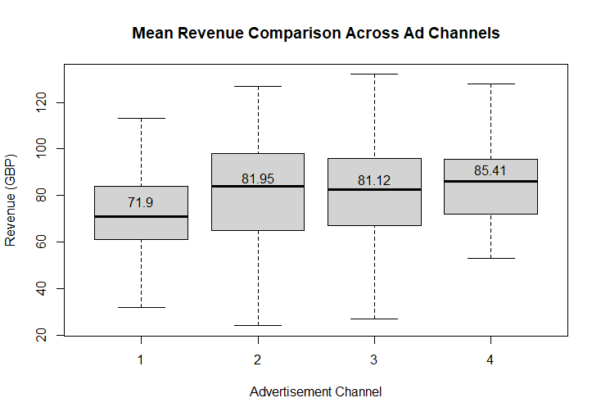

Figure 2.2.3: Comparison of Revenue across Ad Channels

The primary consumer segmentation to target, based on the results mentioned above, is those who may have greater incomes. You can reach this customer segment with helpful coupons and place them in effective advertising channels.

  - Data Preparation:

During the data preparation stage, the focus was on finding critical components that may have a significant impact on the amount of money that customers spent on the website. The following crucial variables were deliberately selected: revenue, voucher interaction, estimated income, and advertisement channel. The advertisement channel variable was formatted appropriately given its categorical character.

Using the caret package, a train-test split was carried out, allocating 70% of the data for training and 30% for testing, in order to verify the predictive model's dependability. This intentional separation ensures that the model is trained on a variety of datasets, which enhances its ability to generalize well to new data.

  - Modelling:

Building a customer revenue prediction model with a focus on important variables such as coupon engagement, expected income, and the channel of advertisements. Given its propensity to accurately represent linear connections between variables, the choice of a linear regression model makes sense in this particular business setting. This is in complete harmony with our previous findings from the correlation matrix, which identified certain linear correlations between factors and revenue. Using this model, the algorithm makes use of past customer data to identify trends, providing insightful information about the most important variables influencing consumer buying behavior.

Figure 2.4.1: Top variables affecting revenue

  - Evaluation:

The implementation of Root Mean Squared Error (RMSE) as a business-oriented statistic guarantees a strong evaluation of the prediction accuracy of the model, offering 'drinks@home.uk' useful data to improve marketing tactics and maximize revenue results. The model's coefficients show the direction and degree of the correlations between each predictor variable and revenue. Notably, the positive coefficients for "Estimated Income", "Seen Voucher", and various advertising channels imply that these variables have a beneficial effect on revenue. All of the p-values for these coefficients are highly significant, suggesting that the observed connections cannot be the result of random chance. A heterogeneous distribution of positive and negative residuals from the model's residual analysis shows sporadic under and overestimation.

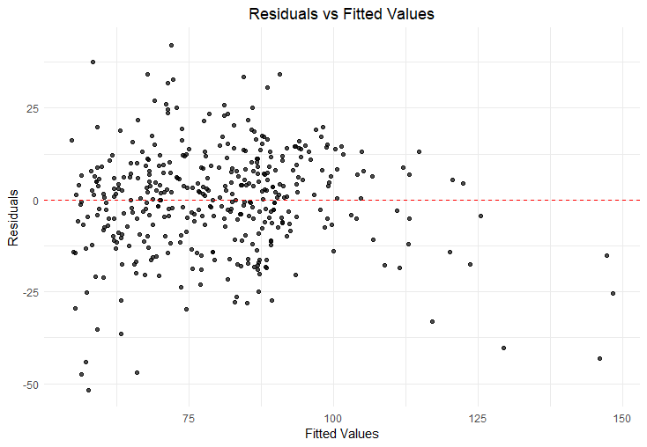

Figure 2.5.1: Linear Regression Model's Residual Analysis

With a mean residual of roughly 0.87 overall, the prediction performance appears to be balanced. Outliers with high residual values, on the other hand, point to regions where the model needs to be improved because they show significant deviations from real results. Expanding the dataset with more consumer data and adding more pertinent aspects should be taken into account to improve performance. A more reliable and accurate forecasting model may result from this tactical improvement.

Metrics like the Root Mean Squared Error (RMSE), which offers a business-oriented assessment of the model's prediction accuracy, are used to assess the overall performance of the model. The RMSE of 13.80 in this instance indicates that the model's projections often differ by £13.80 from the actual income. The RMSE indicates a reasonably accurate prediction, indicating the model's ability in analyzing and predicting client spending behavior on the website, given that the range of revenues runs from £6 to £132.

Strategic Suggestions to Increase Profit:
Applying the knowledge gained from the previous study to evaluate and suggest the best course of action.

- Advertisement to Older Customers: Age did not show up as a significant driver to revenue, despite the linear regression model highlighting parameters like Seen Voucher, Estimated Income, and different advertisement outlets as important contributors. Targeting elderly consumers, however, might still be successful, particularly if they interact more with the channels that have been recognized as the top revenue generators for advertisements, such Channels 2, 4, and 3.
- Offer a Voucher for £20: Offering a £20 voucher could be an effective way to increase consumer spending, as the model highlights a substantial positive association between voucher engagement and revenue. Consumers that use vouchers generate substantially more money on average—roughly £89.50—than their non-using peers, demonstrating the beneficial effects of voucher campaigns.
- Invest More in Influencer Marketing: Although influencer advertising isn't specifically taken into account by the linear regression model, its efficacy may be shown by other analysis or historical data. Influencers who support the best-performing commercial might make a profitable investment if they are explicitly targeted at higher-earning consumers.

  - Conclusion:
Finally, the suggestions made are based on a rational analysis of model coefficients and significance thresholds. The first recommendation, which highlights the absence of statistical significance, advises against pursuing clients who are older than 45. On the other hand, Recommendations 2 and 3 emphasize the use of a voucher strategy and the budget reallocation to influencer advertising, which are both backed by noteworthy gains in revenue. These suggestions offer a doable and realistic method for increasing the revenue of websites. To maintain the continuing alignment of these strategies with corporate objectives, it is advisable to assess and change as needed in response to real-world outcomes.

